Project: | Moffat-Bay
Course: | CSD460-O307 Capstone in Software Development (2261-DD)
Description: | Test Cases for pages: Register, Login, & Home
Date: | 2025/11/14
To complete the test case plan, fill out the information for Project, Course, Description and Date in the header below.
.
TABLE OF CONTENTS
<DESCRIPTION> 2
<DESCRIPTION> 2
<DESCRIPTION> 3

For each test, the developer should: provide a test description, a test objective, the developer name and date tested. For each step, fill out the actions to be taken and describe the expected results, and indicate yes or no for each step depending upon the result. The peer tester should provide their name, date tested, indicate yes or no for each step depending upon the result, and a screenshot (thumbnail) of the result.

Test 1 | Search by Valid Reservation ID
 | Test Objective: Verify a valid reservation ID forwards to the summary with correct data | Developer: Kypton Lantz  Date tested: 2025/11/15 | Peer tester: Julio Pochet  Date tested: 2025/11/28
Step | Action | Expected results: | Developer pass/fail | Tester pass/fail  + Screenshot
1 | Navigate to lookup.jsp | Look up form with options for reservation ID or email is visible | Yes | YES
2 | Enter a known valid ID and click search | Form inputs work as expected and redirects to Summary page | Yes | YES
3 | On the summary page, verify fields | Shows matching ID, customer, and reservation information | Yes | YES
4 | If cancelled, verify UI cues | Status displays CANCELLED in red | Yes | YES
Comments | Search by Reservation ID is properly working.

Test 2 | Search by Email
 | Test Objective: Verify email search returns a list when reservations exist and View links work | Developer: Kypton Lantz  Date tested: 2025/11/15 | Peer tester: Julio Pochet  Date tested: 2025/11/28
Step | Action | Expected results: | Developer pass/fail | Tester pass/fail
1 | Navigate to lookup.jsp | Lookup form visible | Yes | YES
2 | Enter valid customer email and click search | Page stays on lookup and renders a results table of all past reservations for that customer | Yes | YES
3 | Inspect the table | Each row shows ID, check in, check out, status, total, and a “view” button | Yes | YES
4 | Click “view” button | Forwards to summary page for that ID, showing accurate reservation info | Yes | YES
Comments | Search by Email is properly working.

TEST 1 SCREENSHOTS:

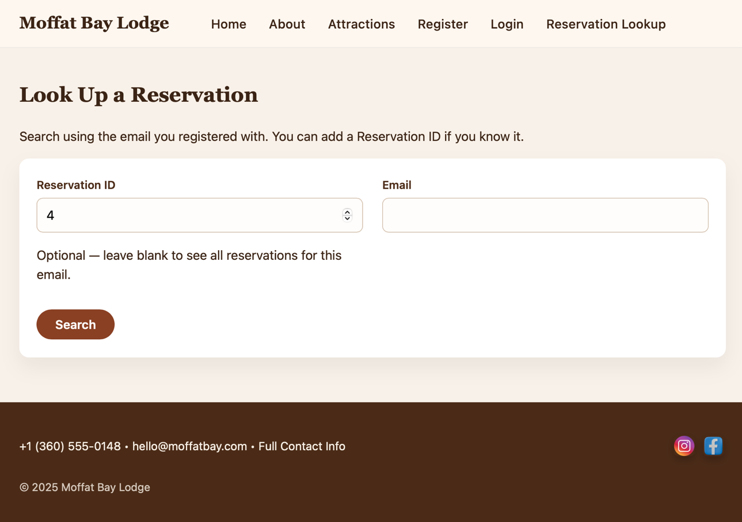

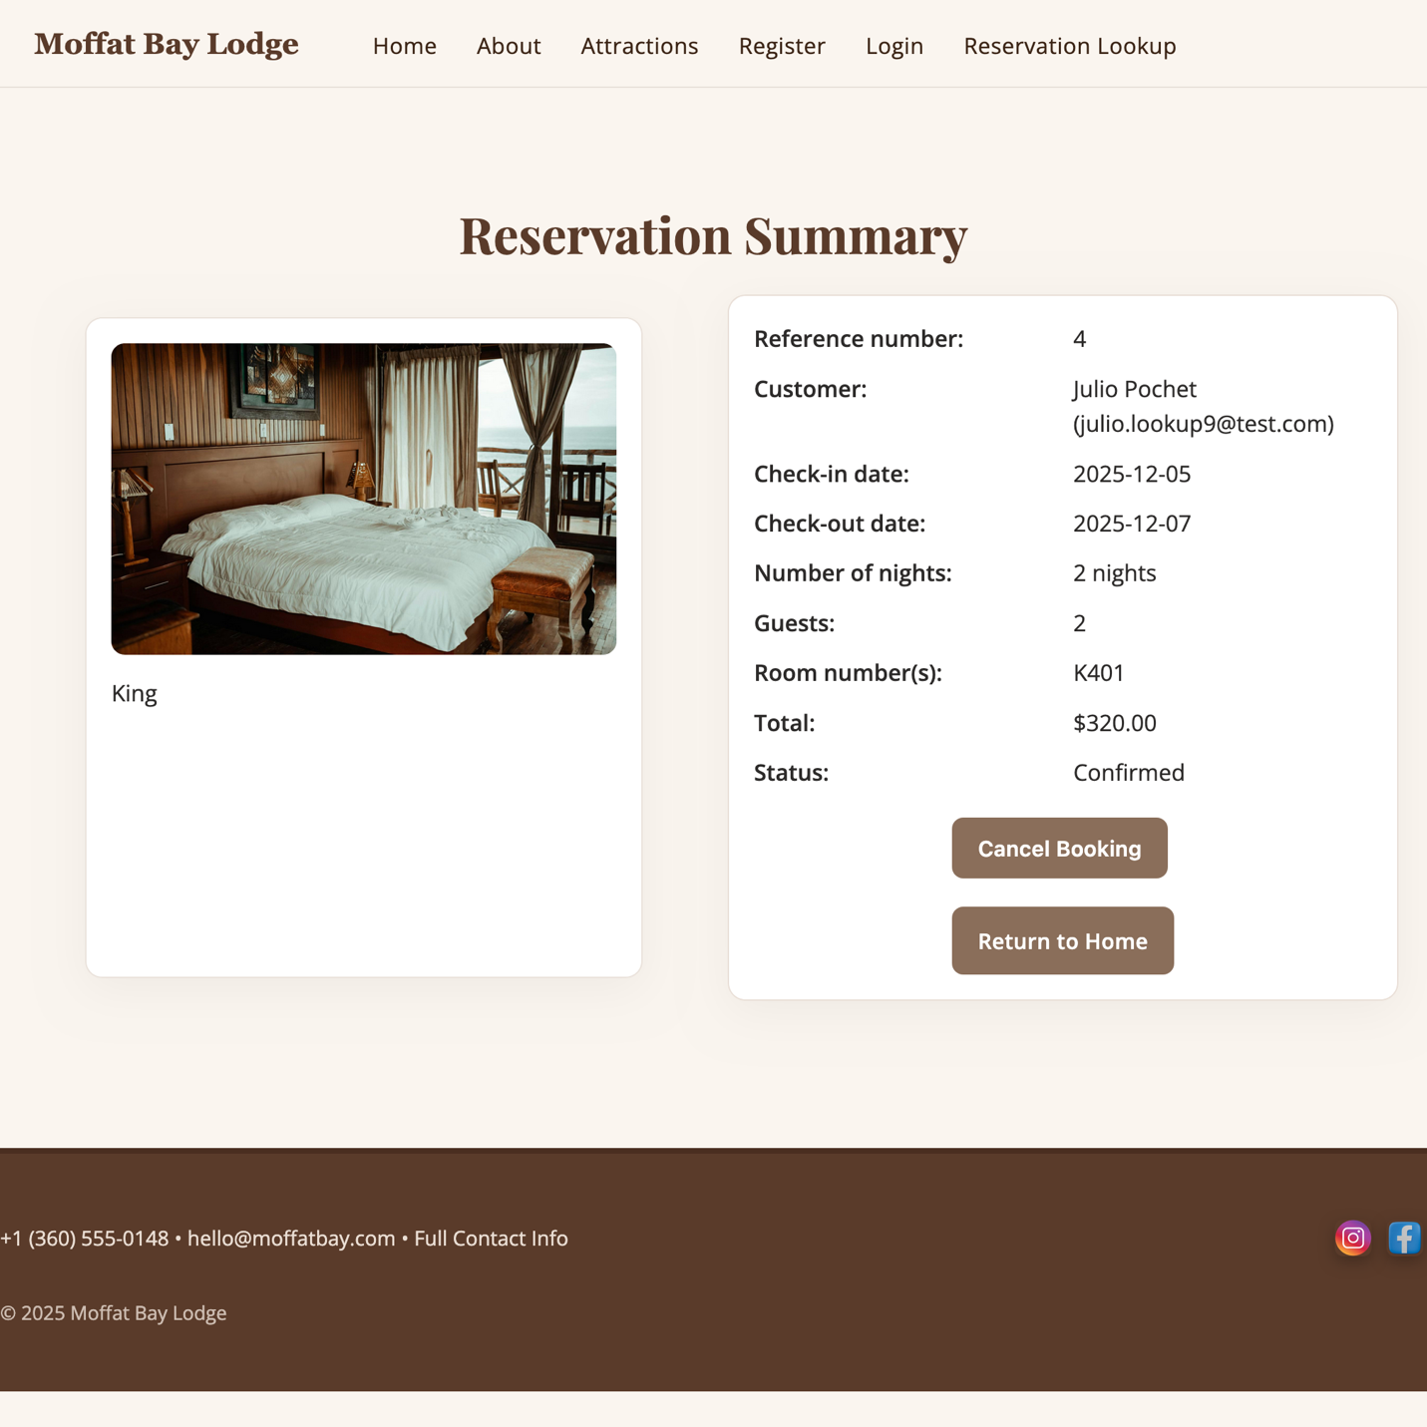
TEST 2 SCREENSHOTS: 